M Language

1. It is use for import data from different sources, like Excel, Text CSV, Folder.
2. It is use for clean and transform the data.
3. Marge and combine the data.
4. Split the Column’s.
5. Replace Value (City Column)

Error – “All the Employee of” Replace with “Nagpur”

And the syntax is :-

#"CorrectedCity" = Table.ReplaceValue(#"Renamed Columns1", "All the Employee of", "Nagpur", Replacer.ReplaceText, {"city"})

in

#"CorrectedCity"

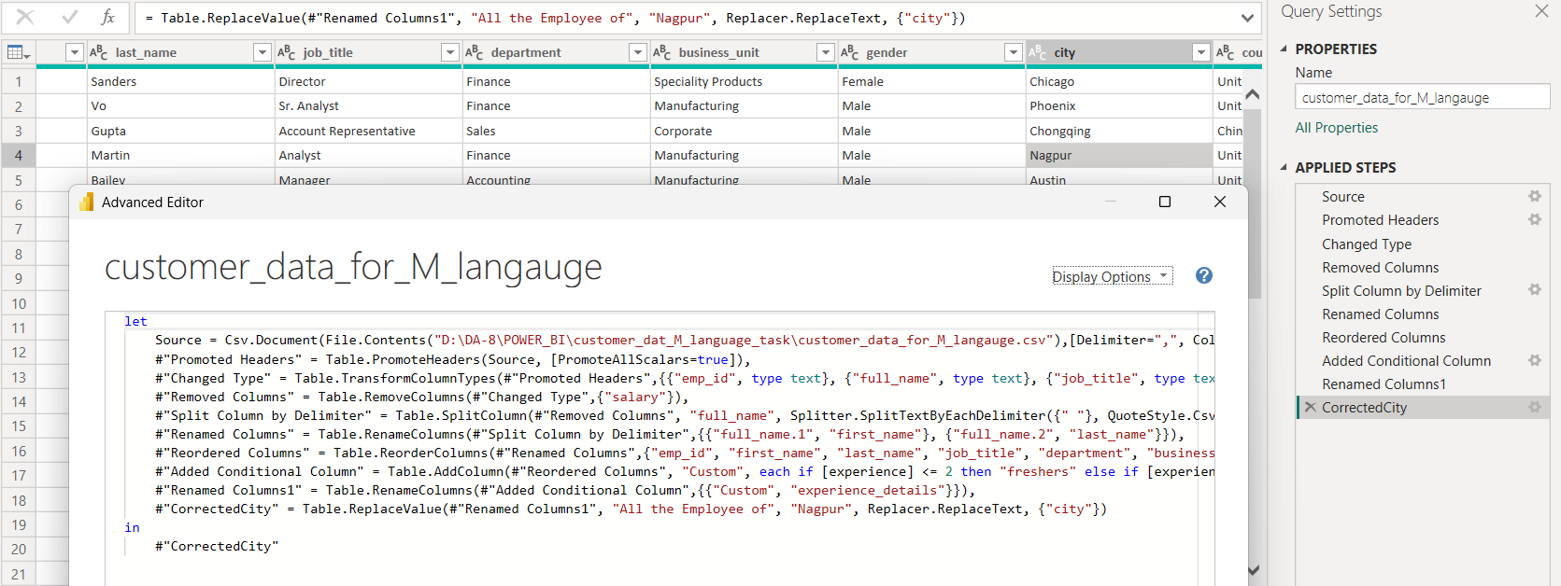

1. Insert New Row

0 - use for starting main new row add ho

#"CorrectedCity" = Table.ReplaceValue(#"Renamed Columns1", "All the Employee of", "Nagpur", Replacer.ReplaceText, {"city"}),

#"Added New Row" = Table.InsertRows(#"CorrectedCity", 0, {

[ emp_id = "E0012", first_name = "Priya", last_name = "Bhambhani", job_title = "Data_Analyst", department = "IT", business_unit = "Manufacturing", gender = "Female", city = "Nagpur", country = "India", age = 27, experience = 1, experience_details = "freshers" ]})

in

#"Added New Row"

